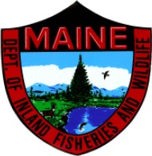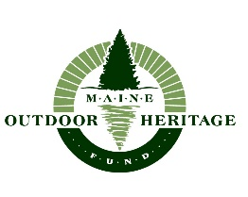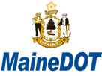

Maine Turtle Roadkill Survey
Results 2018
In 2018, Maine Audubon coordinated the first season of turtle roadkill surveys across Maine, in an effort to identify stretches of road that might have a higher likelihood of turtle mortality. 2018 was the first of a three-year project in which citizen science volunteers monitor pre-selected road segments around Maine to help identify which species of turtles are crossing where, and which road crossings are most hazardous to Maine’s turtles.
In 2018, 65 volunteers attended either of two training sessions offered by staff from Maine Audubon and the Department of Inland Fisheries and Wildlife. At these trainings, participants were training in turtle species identification, road safety, and proper data collection methods using both paper forms and the online data collection tool, iNaturalist. Volunteers were asked to survey their assigned roadways at least 3 times monthly between May and September. Of these trained volunteers, 31 surveyed a total of 105 routes across 11 counties. Fifty-five of those routes had observations of roadkill or wildlife crossing or attempting to cross the road, and 26 of these routes had a total of 99 turtle observations representing 5 species (see Figure 1).

Figure 1.

There were 20 roadside turtle nest sites identified, either through observations of turtles in the act of nesting, or the remains of turtle eggs from predated nests (see Figure 2a and 2b).

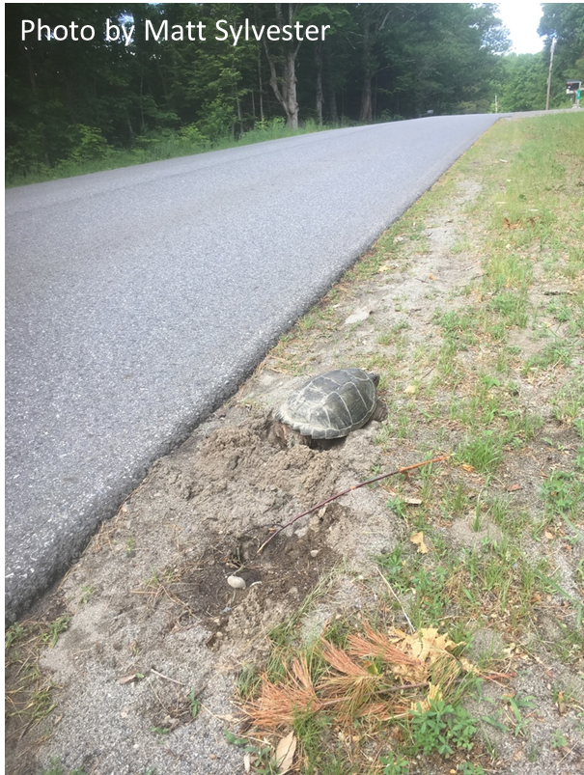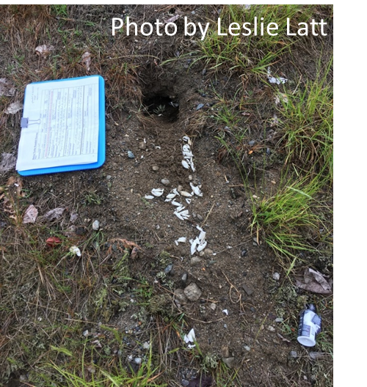
Figure 2a. Figure 2b.
Surveyors were asked to record all observations of roadkill, not just turtles, so we can track road segments with high wildlife mortality beyond just turtle mortality. Because routes were pre-selected using models to identify road segments near potential turtle habitat, turtles were the most represented group (see Figure 3 and Figures 4a-4h).

Figure 3.

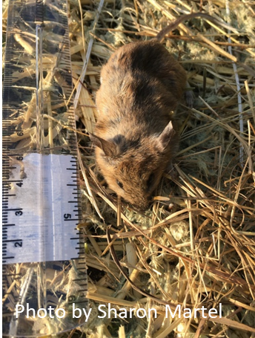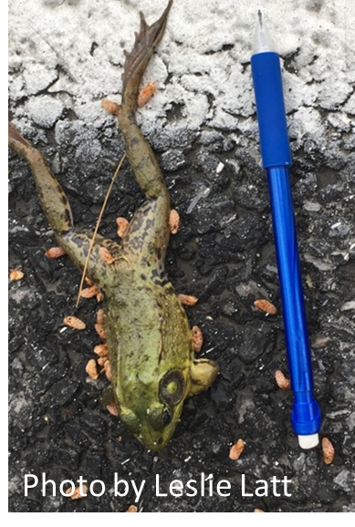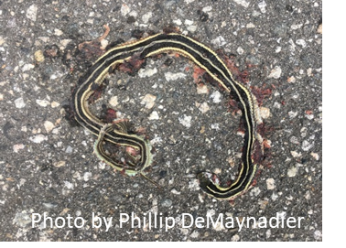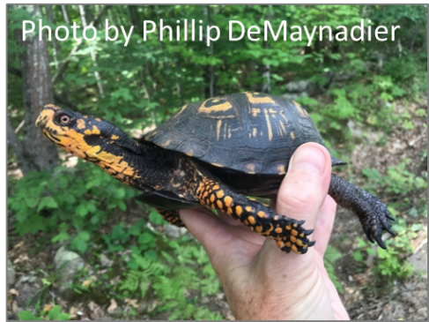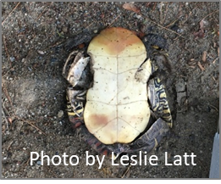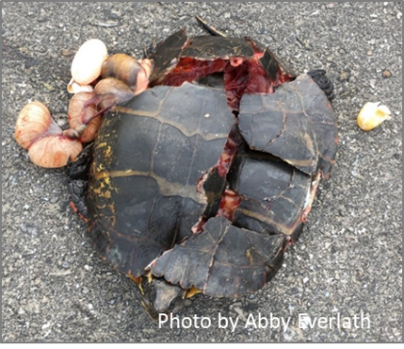
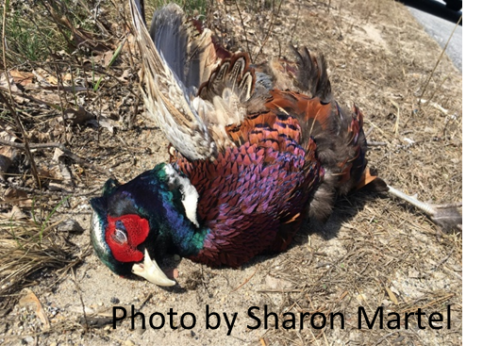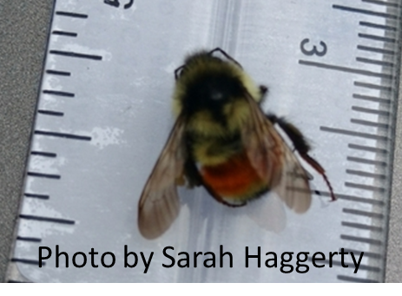
Figure 4a – 4h.

Most data were collected using the iNaturalist mobile application and online iNaturalist data collection tool and added to the Maine Turtle Roadkill Survey iNaturalist project, allowing for easy use by coordinators, surveyors, and other members of the iNaturalist community interested in the data that was collected. For example, curators of the Maine Amphibian and Reptile Atlas Project ,including IFW partners involved in the turtle roadkill survey project, routinely pulled reptile and amphibian data from our project to include in their own datasets.
As we begin the second year, we are preparing for 2 new training sessions, to be held in Gray, Maine on March 30th and in Holden on April 6th (see flyer). Surveyors from 2018 will not be required to attend a training in 2019, but we will provide them with any updated materials and information, such as adjustments made to the data collection protocols, etc. (see training materials).
At the conclusion of this three-year project, we hope to have collected enough data to understand features of the landscape and roadways that might increase or decrease the probability of turtle road mortality. We hope to then use this information to develop mitigation strategies for high mortality sites to reduce or eliminate turtle mortality.

